Assignment (N+) Network Device
Task-1:
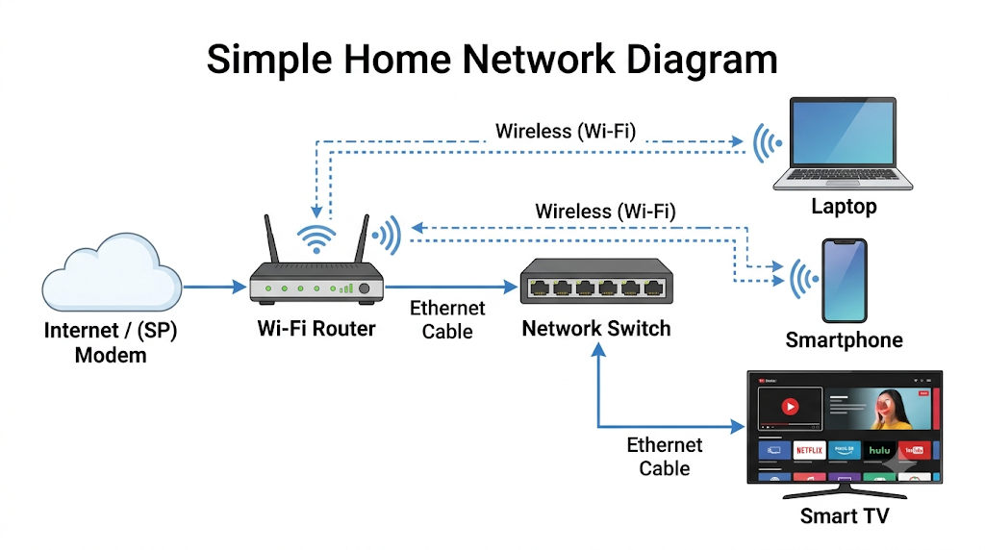

Task-2:
Network Device | Key Function & Intelligence | Real-World Use Case
Router | Acts as the gateway between different networks (like your home LAN and the internet). It reads IP addresses to route data packets to their correct destinations. | Connecting your home network to your ISP so you can access the internet to watch YouTube technical lectures, browse online platforms, or run web vulnerability assessments.
Switch | Connects multiple devices within a single local network (LAN). It is "smart" and uses MAC addresses to forward data only to the specific device that requested it, keeping speeds high. | Connecting multiple desktop computers in a college lab so you can rapidly share files, collaborate on Python projects, or test Cisco Packet Tracer topologies without network bottlenecks.
Hub | A legacy, "dumb" device that connects multiple computers on a LAN. It has no intelligence and simply broadcasts every packet it receives to all connected ports, which causes data collisions and slows down the network. | While mostly obsolete for general networking, a hub is highly useful in a cybersecurity lab environment when you intentionally want to intercept and monitor all network traffic using packet sniffing tools like Wireshark.
Access Point (WAP) | Bridges the gap between a wired network and wireless devices. It takes a wired Ethernet connection and broadcasts it as a Wi-Fi signal. | Providing a strong wireless signal in a specific room so you can connect your smartphone to the internet and stream high-quality audio on the Gaana app without consuming mobile data.

Task-3:
- The Request: You tap "Place Order," and your phone transmits the data wirelessly via radio waves to your home's Access Point.
- Signal Conversion: The Access Point receives the Wi-Fi signal, translates it into wired electrical pulses, and sends it down an Ethernet cable to your Switch.
- Internal Traffic Direction: The Switch reads the hardware address on your data packet and efficiently forwards it to your Router without sending it to unrelated devices.
- The Gateway: The Router translates your local device address into a public IP address and sends the data out of your home network to your Internet Service Provider (ISP).
- Final Destination: The ISP routes your data through the fastest optical paths across the internet until it reaches Zomato's cloud servers to process the order.

